Instructions to apply for the Home Within Reach Awards

1. Visit the website https://www.judgify.me/scanph and review the awards criteria and categories at the bottom of the page.
2. Click the green box that says “Submit an Entry”

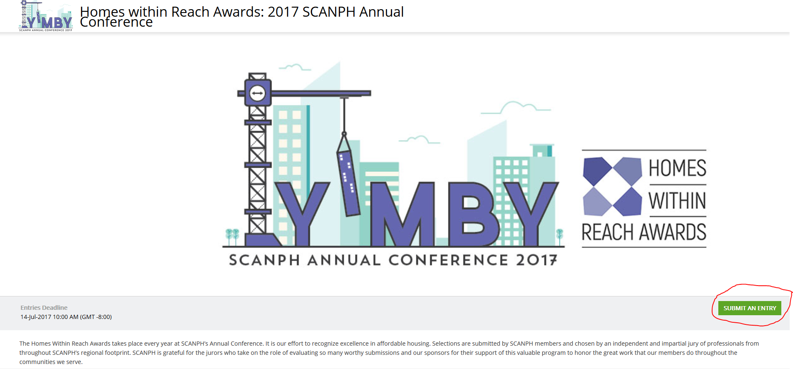
3. As a new user, click the link in blue to register for an entrant’s account. You can return to your application anytime during the application period so that you don’t have to finish your application all at once.

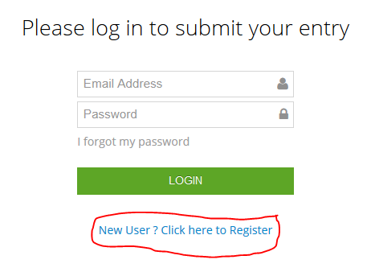

4. Create an entrant profile by filling in the following details:

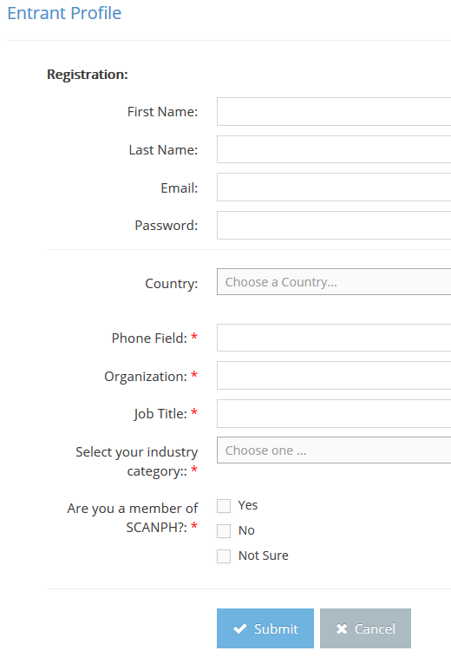
5. Proceed to the “Submission Details” and select the appropriate category for your submission:
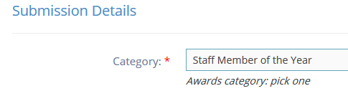
6. After you complete your application, hit “submit.” If you want to apply to a second category, then click “submit and add new.” If you need more time to prepare your application, you may save as a draft and return to the log-in page when you are ready.
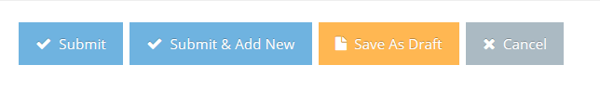

DEADLINE: July 14, 2017

